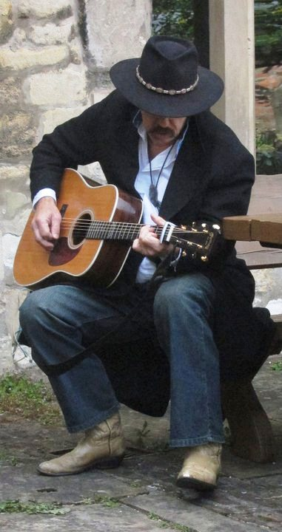

Grammy Nominee, Authentic Appalachian Storyteller,
humorist, award winning acoustic guitarist, singer and songwriter
RICKY SKAGGS says:
“Jerry is as good of a performer you will find that has stayed true to his roots
and remained unblemished by mainstream commercial music.”

y

